Software Requirements Specification

for

Counterfeiting Detection System

**Prepared by:**

**Bhoomika Saxena**

**(2000290120057)**

**Department of Computer Science,**

**KIET Group of Institutions, Delhi-NCR**

**April 26, 2023**

**Table of Contents**

**Table of Contents ii**

**Revision History ii**

**1. Introduction 1**

1.1 Purpose 1

1.2 Document Conventions 1

1.3 Intended Audience and Reading Suggestions 1

1.4 Product Scope 1

1.5 References 1

**2. Overall Description 2**

2.1 Product Perspective 2

2.2 Product Functions 2

2.3 User Classes and Characteristics 2

2.4 Operating Environment 2

2.5 Design and Implementation Constraints 2

2.6 User Documentation 2

2.7 Assumptions and Dependencies 3

**3. External Interface Requirements 3**

3.1 User Interfaces 3

3.2 Hardware Interfaces 3

3.3 Software Interfaces 3

3.4 Communications Interfaces 3

**4. System Features 4**

4.1 System Feature 1 4

4.2 System Feature 2 (and so on) 4

**5. Other Nonfunctional Requirements 4**

5.1 Performance Requirements 4

5.2 Safety Requirements 5

5.3 Security Requirements 5

5.4 Software Quality Attributes 5

5.5 Business Rules 5

**6. Other Requirements 5**

**Appendix A: Glossary 5**

**Appendix B: Analysis Models 5**

**Appendix C: To Be Determined List 6**

**Revision History**

|  |  |  |  |
| --- | --- | --- | --- |
| **Name** | **Date** | **Reason For Changes** | **Version** |
|  |  |  |  |
|  |  |  |  |

# Introduction

*At the time of buying clothes, there is a possibility that we are getting a fake product in the name of a renowned brand by paying the amount of the original one and sometimes it becomes difficult for the customer to decide whether it is real or fake. Hence a system is required to check the authenticity of the product.*

## Document Conventions

*The document was created based on the IEEE Template for system requirement specification document.*

## Intended Audience and Reading Suggestions

* + - Project Guides
    - Externals
    - Mentors
    - Examiners
    - Faculties

## Product Scope

*This system can be used in various other industries also like in medicines, electronic devices, accessories, toys, perfumes, aircraft-parts, etc. and through the system we can detect which product is fake or real. Governments lose out on unpaid tax and incur large costs in enforcing intellectual property rights.*

## References

* + - <https://www.sciencegate.app/document/10.1080/0144929x.2021.2022209>
    - <https://www.sciencegate.app/document/10.22214/ijraset.2022.39907>
    - <https://www.researchgate.net/publication/271098121_An_introduction_to_using_QR_codes_in_scholarly_journals>
    - <https://developers.google.com/ml-kit/vision/barcode-scanning>
    - <https://arxiv.org/abs/1412.6572>
    - <https://journalofbigdata.springeropen.com/articles/10.1186/s40537-019-0268-2>

# Overall Description

## Product Perspective

*The market cap of fake clothing products in the year 2021 was over 1 billion. In India alone, it is growing rapidly at about 20% increase every year. We all know names of numerous fake products markets such as PALIKA BAZAR, SAROJINI NAGAR MARKET , etc. This causes a major hamper in the brand’s reputation as well as the user experience. Not only this by selling these illegal goods many people are able to avoid the taxes they’ve to pay with it, which is ultimately hampering our country’s economy.*

## Product Functions

* + - *To determine the authenticity of product*
    - *To stop reselling of apparel*
    - *To reduce the loss of company*
    - *To uphold the authentic brand’s reputation*
    - *To stop tax evasion caused due to sale of illegal clothes*

## User Classes and Characteristics

***Technicians:*** *These users are responsible for installing, calibrating, and maintaining the counterfeit detection system. They should have a strong technical background in SRS and experience with electronic equipment. They should also have a good understanding of the counterfeit detection system's operating principles, troubleshooting techniques, and safety procedures.*

***Inspectors:*** *These users are responsible for performing inspections of SRS components to detect counterfeit parts. They should have a good understanding of SRS components, including their physical and functional characteristics. They should also have experience with inspection procedures and be trained on how to identify counterfeit parts.*

***Engineers:*** *These users are responsible for designing and testing the counterfeit detection system. They should have a strong background in engineering, with expertise in electronic and software design. They should also have experience with testing procedures and be familiar with the standards and regulations governing SRS and counterfeit detection systems.*

***Supervisors:*** *These users are responsible for overseeing the operation of the counterfeit detection system and ensuring that it meets the required performance standards. They should have strong communication and leadership skills, with the ability to manage a team of technicians, inspectors, and engineers. They should also have a good understanding of SRS and counterfeit detection systems, as well as the regulatory requirements governing their use.*

***End-users:*** *These users are the ultimate beneficiaries of the counterfeit detection system, as they rely on SRS to provide them with protection in the event of a crash. They should have a basic understanding of SRS and be aware of the risks associated with counterfeit parts. They should also be informed about the counterfeit detection system and its role in ensuring the safety and reliability of SRS.*

## Operating Environment

*Our app is a complete software solution. It would be a web app and have three different modes. One for the companies/ admins at backend, for the retail shops and lastly for the users to check the authenticity.*

*This would however require a ‘QR code scanner’ at the retail shops to scan the product while billing to mark that it is sold. Other than that no further requirements are need and all the work could be done via our web app only. With the use of state-of-the-art technologies such as Python, various libraries, MongoDB, PostgreSQL, Figma, HTML front end, React, Node, Django, Apache Tomcat, and AWS, our solution promises to be a complete software solution using web applications.*

## Design and Implementation Constraints

***Technology compatibility:*** *The web app should be compatible with the specified technologies, including Python, various libraries, MongoDB, PostgreSQL, Figa, HTML front end, React, Node, Django, Apache Tomcat, and AWS.*

***Security:*** *The web app should be designed with robust security features to protect against potential security threats, including unauthorized access, data breaches, and other vulnerabilities.*

***Scalability:*** *The web app should be designed to handle a potentially large volume of data and user traffic, and should be scalable to accommodate future growth and changes in demand.*

***User experience:*** *The web app should be designed with a user-friendly interface that allows users to easily navigate and interact with the app. The design should be consistent throughout the app and should follow best practices for usability and accessibility.*

***Performance:*** *The web app should be designed for optimal performance, with efficient and optimized code that can handle multiple requests and queries simultaneously without slowing down or crashing. The app should also be optimized for quick load times and smooth user experience.*

***Integration:*** *The web app should be designed to integrate with other systems and services, such as authentication systems, payment gateways, and shipping services.*

***Compliance:*** *The web app should comply with relevant laws and regulations, such as data privacy laws, consumer protection laws, and intellectual property laws. The app should also comply with industry standards and best practices for security, performance, and user experience.*

## User Documentation

***Overview:*** *Provide an overview of the web app and its purpose, explaining how it will help to prevent the sale of counterfeit clothes.*

***System requirements:*** *List the system requirements needed to access and use the web app, including compatible browsers and operating systems.*

***User classes:*** *Explain the different user classes and their roles in the system, including administrators, companies, and customers.*

***Features:*** *Describe the features of the web app, including how users can search for and verify the authenticity of clothes, report suspicious activity, and manage their accounts. User interface: Provide a walkthrough of the user interface, explaining how users can navigate the app, perform searches, and use different features.*

***Troubleshooting:*** *Include troubleshooting tips and common issues that users may encounter, along with solutions to these problems.*

***Security:*** *Explain the security features of the web app, including how user data is protected, and how the app detects and prevents fraudulent activity.*

***Technical information:*** *Provide technical information about the app, including the technologies used, database architecture, and other relevant technical details.*

***Contact information:*** *Include contact information for technical support or customer service, including email addresses, phone numbers, and hours of operation.*

## Assumptions and Dependencies

***Assumptions:***

* *The system is designed to detect counterfeit clothes based on their security features. It assumes that the clothes being checked have genuine security features that can be analyzed and compared to the system's database.*
* *The system assumes that users have a basic understanding of security features and can identify genuine clothes from counterfeit ones.*
* *The system assumes that users will follow the instructions provided in the user manual for proper use and maintenance of the system.*

***Dependencies:***

* *The Counterfeit Detection System requires a mobile phone to operate. Users must ensure that the mobile phone has enough battery and a QR code Scanner to scan the generated QR code.*
* *The system depends on the accuracy and completeness of its security features database. Users should ensure that the system's database is up-to-date and includes all the latest security features.*
* *The system's accuracy depends on the condition of the clothes being checked. Users should ensure that the clothes are clean, flat, and not damaged or folded, as these factors can affect the accuracy of the system.*
* *The system may depend on external factors, such as lighting conditions and environmental factors, to operate effectively. Users should ensure that the system is used in suitable lighting conditions and in an environment free from excessive dust, smoke, or other contaminants.*

*By considering these assumptions and dependencies, users can ensure that they get the best results from the Counterfeit Detection System for SRS and minimize the risk of errors or false positives.*

# External Interface Requirements

## User Interfaces

***Home page:*** *The home page should include a brief introduction to the app, along with a search bar that allows users to search for clothes by brand, type, or other criteria.*

***Authentication:*** *The app should require users to authenticate themselves in order to access certain features, such as reporting suspicious activity or managing their accounts. The authentication process should be simple and secure, and may include options such as username and password, social media login, or two-factor authentication.*

***Product verification:*** *When a user searches for a particular item of clothing, the app should display information about that product, including the brand, type, and other relevant details. The app should also provide a way for users to verify the authenticity of the product, such as by scanning a QR code or entering a serial number.*

***Reporting suspicious activity:*** *The app should include a feature that allows users to report suspicious activity, such as the sale of counterfeit clothes or other fraudulent activity. This feature should be easily accessible from the home page, and should include a form that allows users to provide details about the suspicious activity.*

***Account management:*** *The app should allow users to manage their accounts, including updating their personal information, viewing their purchase history, and accessing support resources. The account management feature should be easy to use and should include clear instructions for each task.*

***Help and support:*** *The app should include a help and support section that provides users with answers to common questions, troubleshooting tips, and contact information for technical support or customer service.*

## 3.1 Software Interfaces

*Our Web app would use the following technologies on the software interface.*

1. ***qrcode***
   1. *We will be using a python library called ‘qr code’ at the backend for the generation of qr codes.*
2. ***pyzbar***
   1. *We will be using a python library called ‘qr code’ at the backend for the scanning of qr codes.*
3. ***pgAdmin***
   1. *Database generation and administration*
4. ***SQLAlchemy***
   1. *For database connectivity we*
5. ***UI/UX*** 
   1. *We will use Figma and VS Code for UI/UX generation.*
6. ***Web Application***
   1. ***Front End:***
      1. *HTML*
      2. *CSS*
      3. *JS*
      4. *REACT*
   2. ***Back End*** 
      1. *Python*
      2. *nodeJS*
      3. *django*
      4. *Flask*
   3. ***Database*** 
      1. *postgreSQL*
   4. ***Application Server*** 
      1. *Apache tomcat*
   5. ***Cloud Platform***
      1. *AWS*

## 3.3 Communication Interfaces

*This will support scanning of QR code using QR code scanner. The user will have to make sure of a good internet connection and network.*

# System Features

*This system is determining whether the product is authentic or fake.*

*This detection system also determines the sold status of the product so that it cannot be resold.*

*This system also ensures that the government gets the tax percentage by the transaction of clothing products at the time of purchasing it.*

*This system also upholds the authentic brand’s reputation.*

*This system also helps in reduction of the loss of the company by counterfeiting clothing products.*

## 4.1 Feature 1-

***Scan QR code.***

*This will be a primary feature and the main actor of this feature is Customer.*

*To access the authenticity and details of the Product the customer will scan the QR code on the Product.*

***Stimulus/Response Sequences***

***Actor Actions***

* *Actor scans the QR code.*

***System Responses***

* *System responds with either alert or redirection on the company's website based on whether the product is fake or real.*

## 4.2 Feature 2-

***Redirection to company's website****.*

*This will be a primary feature and the main actor of this feature is System.*

*System will redirect to the company's website if the scanned QR code is valid where all the details about the product will be seen.*

***Stimulus/Response Sequences***

***Actor Actions***

* *Actor scans the QR code.*
* *Identify the QR code is valid.*

***System Responses***

* *System responds with either alert or redirection on the company's website based on whether the product is fake or real.*
* *System redirects the customer to the Company's website.*

## 4.3 Feature 3-

***Alert Generated***

*This will be a primary feature and the main actor of this feature is System.*

*System will generate the alert if the scanned QR code is invalid or the Product is already sold.*

***Stimulus/Response Sequences***

***Actor Actions***

* *If Identify the QR code as valid*
* *Product is already sold*
* *If Identify the QR code as invalid*

***System Responses***

* *System redirects the customer to the Company's website and checks for the sold status.*
* *System generates an alert to the customer.*
* *System generates an alert to the customer.*

## 4.4 Feature 4-

***View Product details.***

*This will be a primary feature and the main actor of this feature is Customer.*

*The customer gets access to the details of the Product like its sold status,price etc.*

***Stimulus/Response Sequences***

***Actor Actions***

* *If Identify the QR code as valid*
* *Actor checks the Product details*

***System Responses***

* *System redirects the customer to the Company's website.*
* *System shows the details of the Product to the Customer.*

## 4.5 Feature 5-

***Post Reviews.***

*This will be a primary feature and the main actor of this feature is Customer.*

*The customer can post the reviews about the Product.*

***Stimulus/Response Sequences***

***Actor actions***

* *Actor will post the reviews.*

***System Responses***

* *System will update the reviews on the website.*

# Other Nonfunctional Requirements

## 5.1 Performance Requirements

*Performance is one of our major concerns. Since the core objective of this project is to efficiently manage all the queries raised for authenticity,we have to make our website fast and efficient. We shall achieve this through minimal response times when users will enter our website. Our website should be able to identify the authenticity of a product with the help of a scanner.*

## 5.2 Safety Requirements

*Since this is an online platform, we won’t have to deal with safety issues much often. But to avoid unnecessary risks, and potential crises, customers will be able to report the issue/problem to us for violating community standards.*

## 5.3 Security Requirements

*Users will be able to redirect to the website if the QR code on the product is valid.This ensures the security of the website.*

## 5.4 Software Quality Attributes

* *Accurate and precise processes must be performed by the system to avoid problems.*
* *The system must be flexible and should be easily modified.*
* *Execution process must be fast and responsive.*
* *UML will be used in the development process.*
* *The GUI of the system will be user friendly.*
* *The software is a web-based application. So it is platform independent.*

## 5.5 Business Rules

*We can create partnerships with different brands. If our app becomes popular they will pay us commission for minimizing the sale of fake products of their brand.*

**Appendix A: Glossary**

**AWS: Amazon Web Services**

**TrueCheck: Our Software’s name**

**QR Code: Quck Response Code**

**SRS: Software Requirement Specification**

**UI: User interface**

**UX: User Experience**

**HTML: Hyper text markup language**

**CSS: Cascaade style sheets**

**JS: JavaScript**

**Level 0 DFD: Data flow diagram of level 0**

**Level 1 DFD: Data flow diagram of level 1**

**Level 2 DFD: Data flow diagram of level 2**

**ER Diagram: Entity Relationship diagram**

**UID: Uniqure identification id**

**DB: Databse**

**Appendix B: Analysis Models**

Level 0 DFD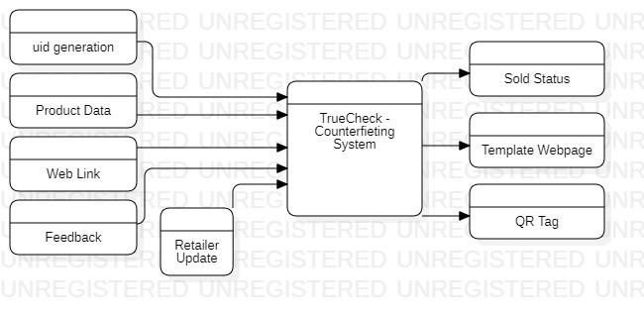

Level 1 DFD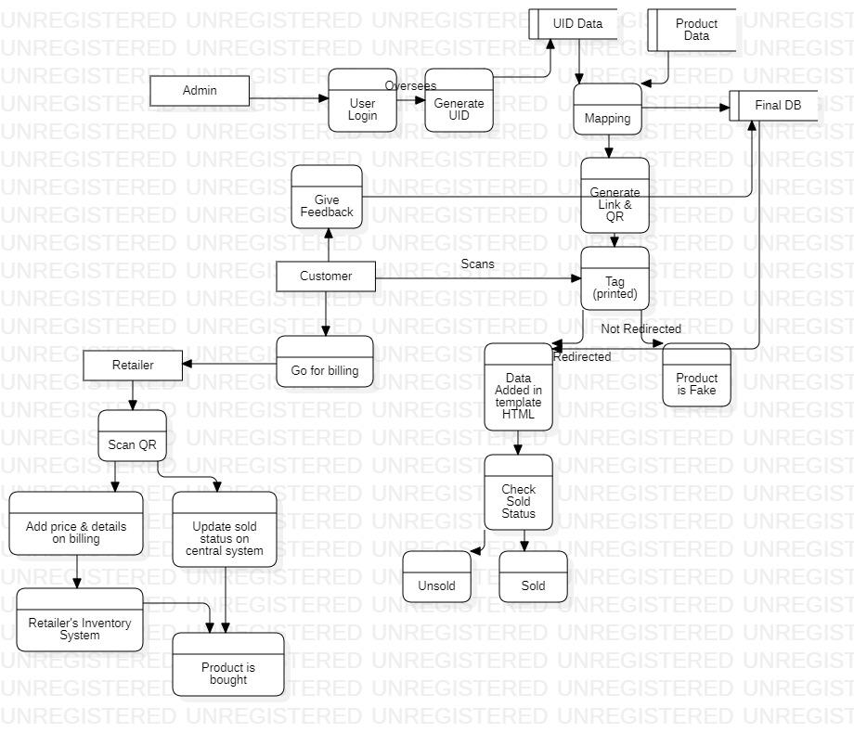

Level 2 DFD - Login

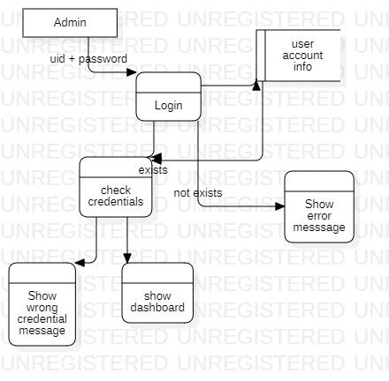

Level 2 DFD: Uid generation

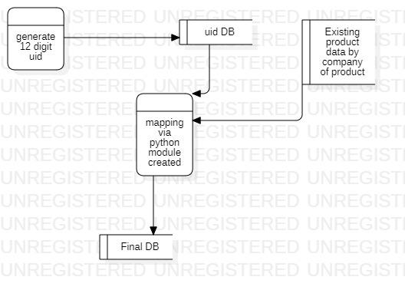

Level 2 DFD: Mapping

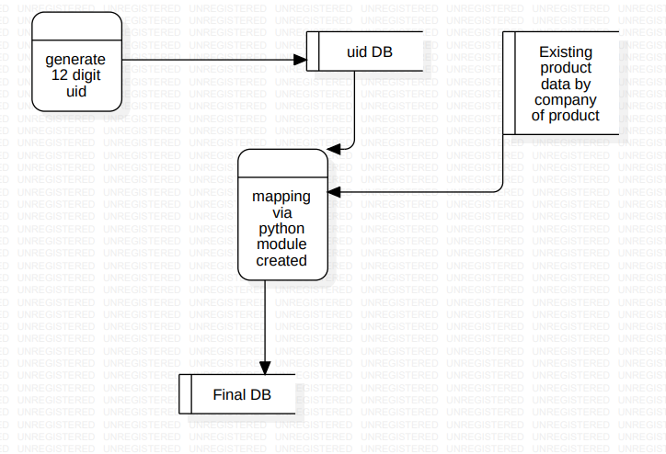

Level 2 DFD: Link Generation

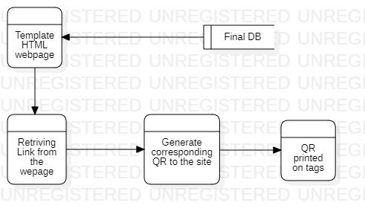

Level 2 DFD: Link Check

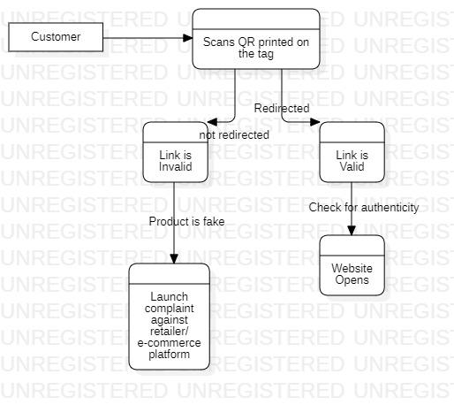

Level 2 DFD: Sold Status

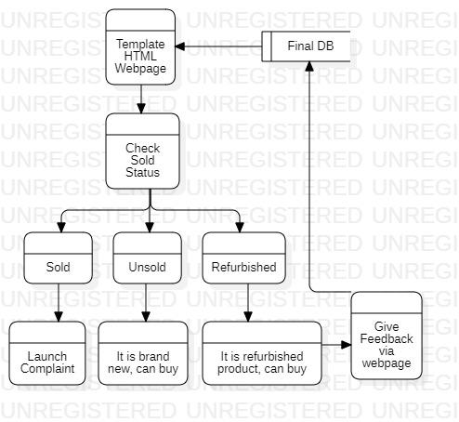

Level 2 DFD: Retailer

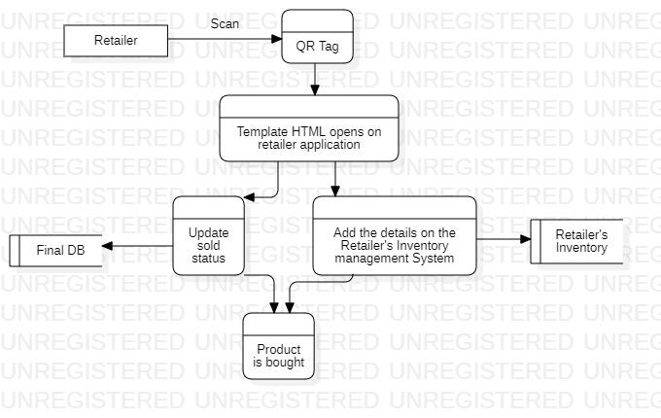

ER Diagram

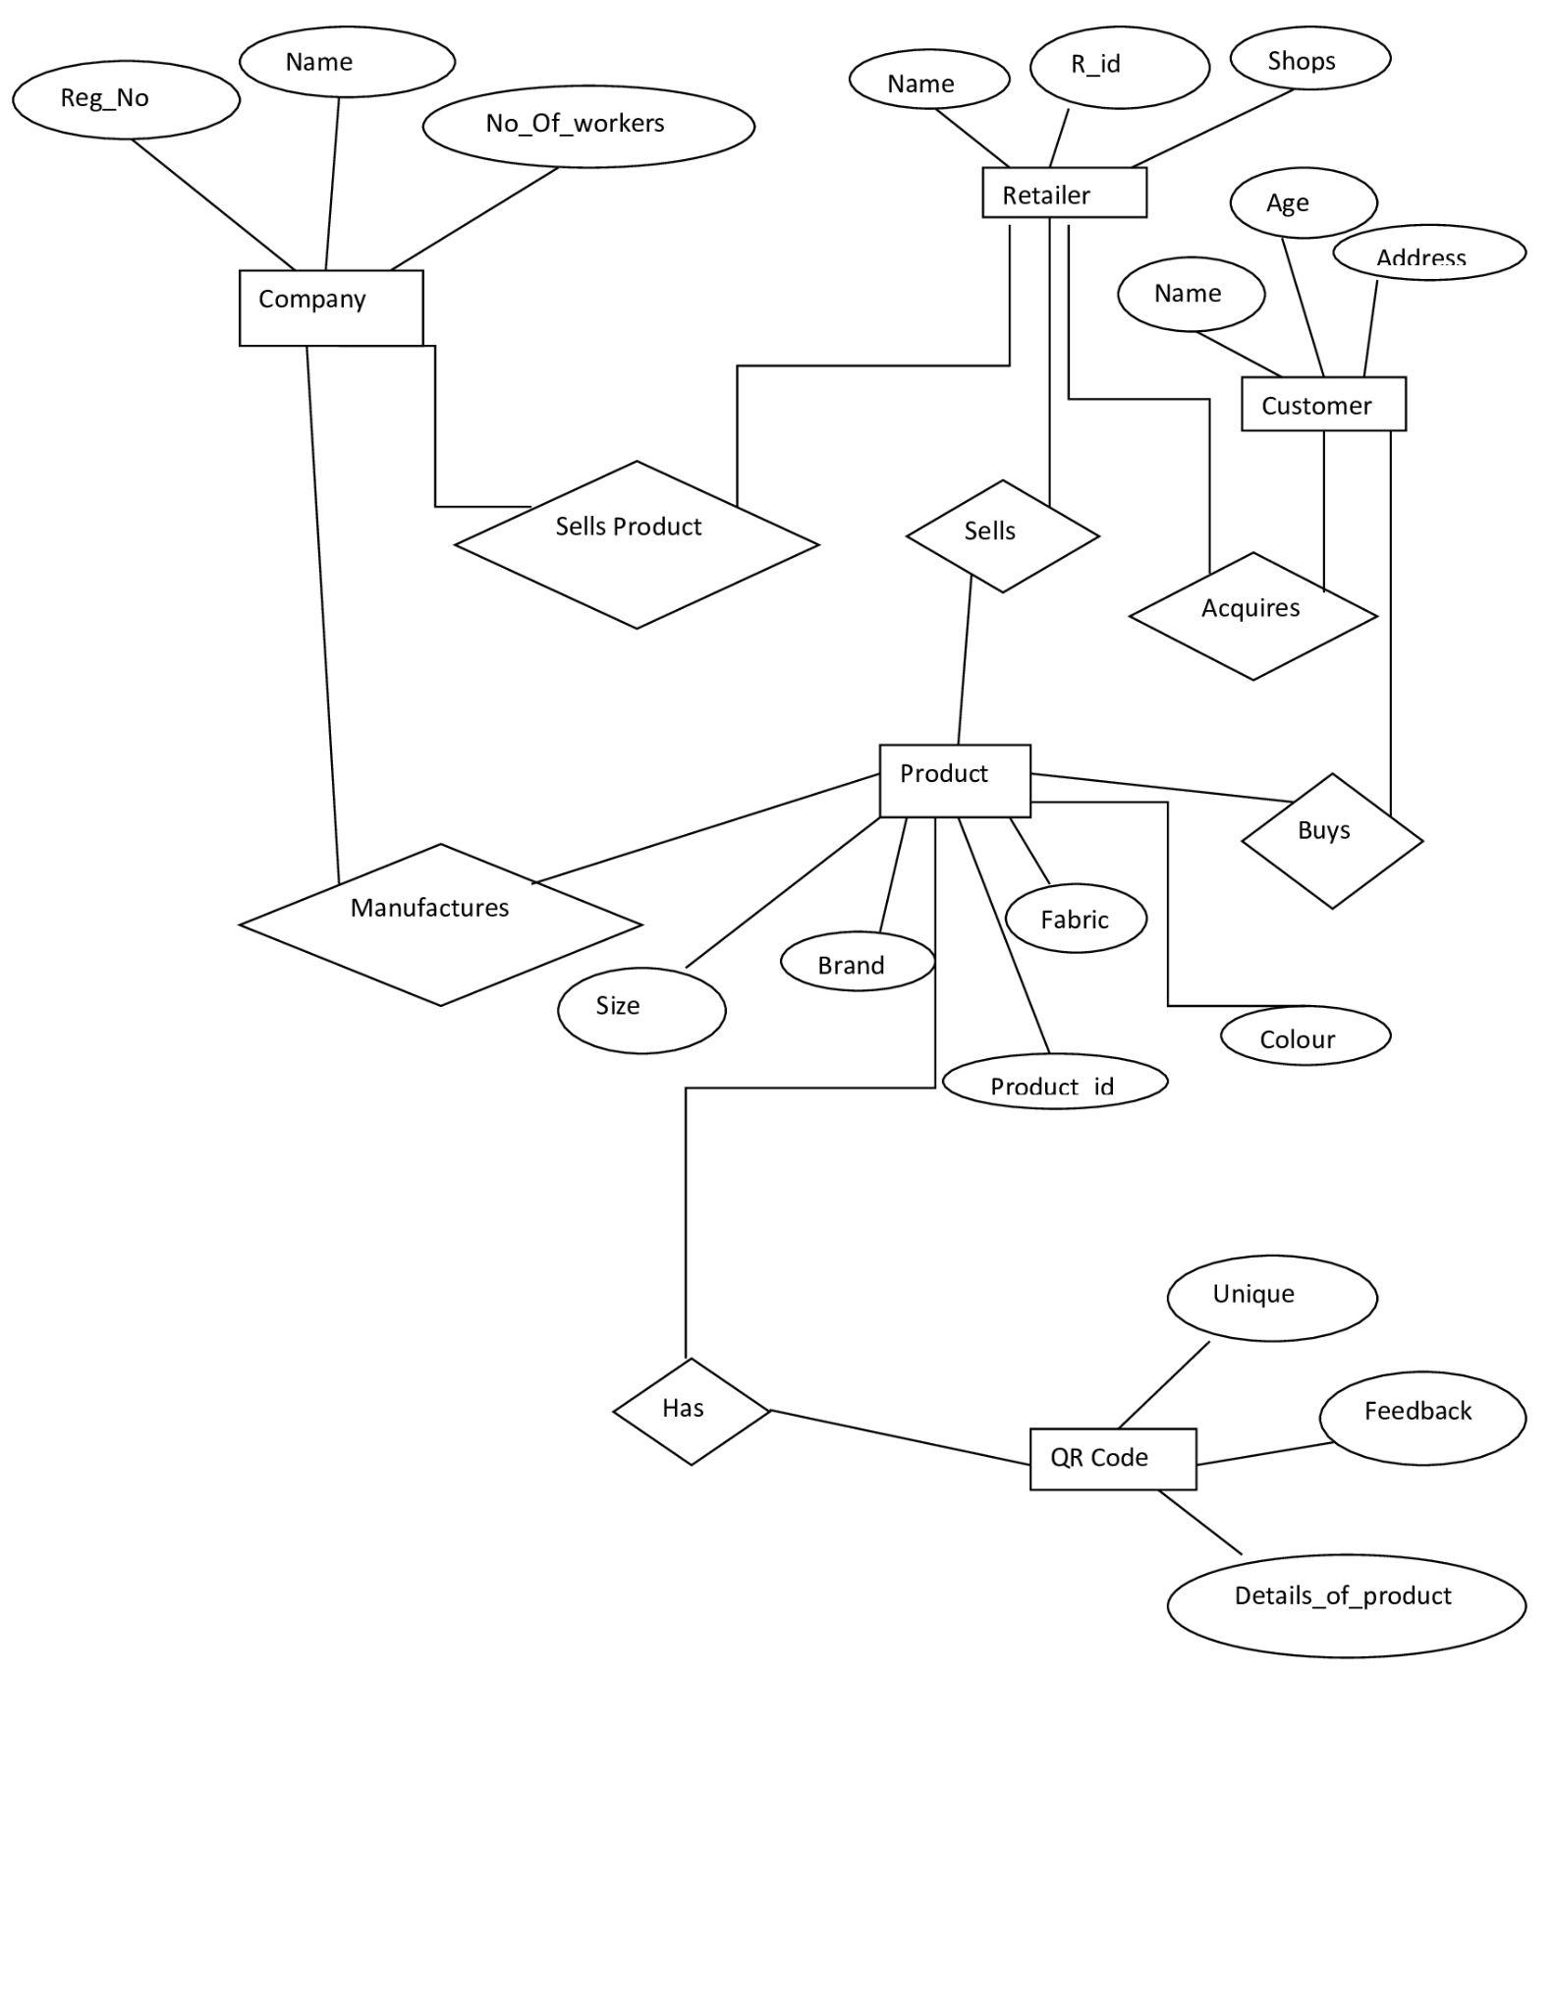

**Appendix C: To Be Determined List**

* *Getting familiar with all the technologies used in the creation of application*
* *Creation of dummy dataset for testing the application*
* *Creating a strong backend system*
* *Integrating all the technologies for testing*
* *Final creation of the WEB APP*
* *Implementing the same using an android application*